GOLF TOURNAMENT UWGC 2019 Kyiv PRICE & PACKAGE

PRE TOUR UWGC 2019 Kharkiv PRICE & PACKAGE

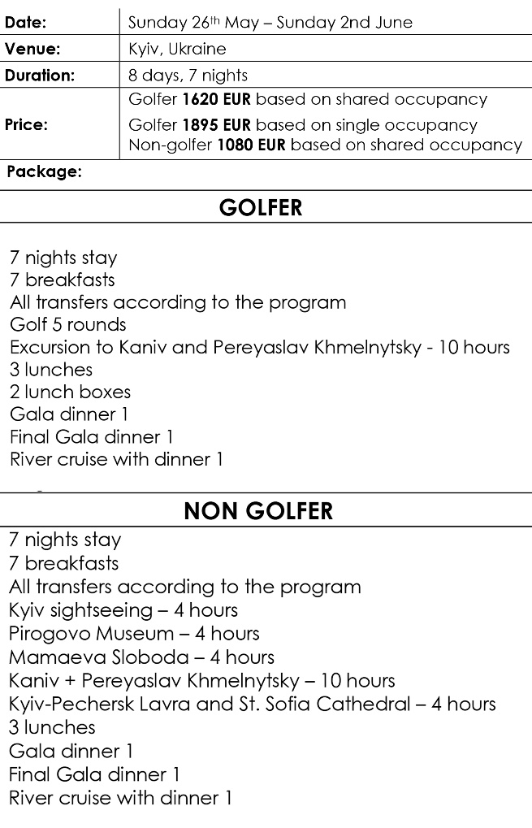
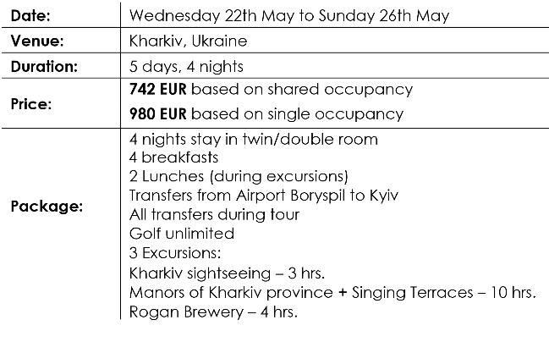

POST TOUR UWGC 2019 Lviv PRICE & PACKAGE

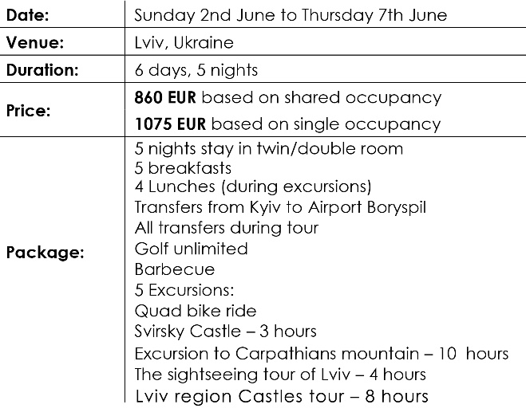

Early bird registration (before 15/09/2018):
Golfer (based on shared occupancy) 1620 EUR
Golfer (based on single occupancy) 1895 EUR
Non-golfer (based on shared occupancy) 1080 EUR

Registration after 01/12/2018:  Golfer (based on shared occupancy) 1720 EUR  Golfer (based on single occupancy) 1995 EUR  Non-golfer (based on shared occupancy) 1180 EUR | Late registration (after 01/03/2019):  Golfer (based on shared occupancy) 1920 EUR  Golfer (based on single occupancy) 2195 EUR  Non-golfer (based on shared occupancy) 1380 EUR  Terms payment

Cancellation policy
Golf Tournament/ Kyiv

Terms of payment:
Within 15th September 2018 – 50%
Cancellation after 15 September 2018 | 80 % refund will be made
Cancellation after 21 March 2019 | 40% refund will be made
Cancellation after 01 May 2019 | 10% refund will be made

Within 01st December 2018 – 80%
Within 01st March 2019 – 100%

Pre Tour/ Kharkiv
Cancellation after 21 March 2019 | 80% refund will be made
Cancellation after 01 May 2019 | 65% refund will be made
Cancellation after 10 May 2019 | 15% refund will be made

Post Tour/ Lviv
Cancellation after 01 April 2019 | 65% refund will be made
Cancellation after 15 May 2019 | 15% refund will be made

Payment methods

Bank Transfer:  After registration you will receive on your e-mail an invoice (with all bank details).  Your payment should be made to :  Travel Company “SPUTNIK Kyiv” Ltd.  Bank details:  Bank Beneficiary:  FIRST UKRAINIAN INTERNATIONAL BANK  4, Andriivska Str., Kyiv, 04070, Ukraine.  SWIFT BIC: FUIBUA2X  Acc.26001962506486 | Credit card :  After registration you will receive on your e-mail an invoice from Liqpay (secure payment system of the largest Ukrainian bank «Privatbank»)  To pay by credit card (VISA/MasterCard) you need a mobile phone, on which will be sent one-time SMS-password. This is a requirement of a safety system, after that you will be able to make payment.

Personal Details
NAME

Nationality
SURNAME
Date of Birth

Address
Passport Expiry

Passport Number

Telephone
numbers
E:mail

If you have partner
shared
occupancy
single
occupancy
Level of participation
NON-GOLFER
GOLFER
X
X

KHARKIV

KYIV

LVIV

All Days
Day 6
Day 4
Day 3
IN GC GOLFSTREAM / PER ROUND
UWGC 2019 KYIV GOLF EXTRAS

Golf Club
Handicap

Badge Name
National Team
Premium Rental Clubs 23 EURO
Premium Rental Clubs 23 EURO
Buggy Hire 58 EURO

Private Caddy 70 EURO

Pull Troley 6 EURO
MEN
S
M
L
XL
XXL
UWGC LOGO SHIRTS
IN GC KOZYN to be sent in a separate e-mail
LADIES

Partner in Kyiv personal details

E:mail

Telephone
numbers

Address

Passport Expiry

Passport Number

Date of Birth

Nationality
SURNAME
NAME

Badge Name

National Team
If your partner is a GOLFER

Golf Club
Handicap

Premium Rental Clubs 23 EURO
Day 6
All Days
Day 3
Day 4
UWGC 2019 KYIV GOLF EXTRAS for PARTNER / PER ROUND
City

Departure

Flight number
Time

Date
Airport

Arrival
City
Partner flight details
LADIES
MEN

XXL
XL
L
M
S

Buggy Hire 58 EURO

Private Caddy 70 EURO

Pull Troley 6 EURO

UWGC LOGO SHIRTS for PARTNER

Date
Airport
Time

Bus ride to Svirsky Castle

Bus ride to Svirsky Castle
or

Quad bike

or

E:mail

Surname

Name
If you have partner :

Quad bike
Day 2 Monday 03.06.19/ Choose one of:
X
X

shared
occupancy

single
occupancy
POST TOUR UWGC 2019 Lviv

or
or

E:mail
Surname

Name
If you have partner :

single
occupancy
shared
occupancy

X
X

Day 4 Saturday 25.05.19 / Choose one of:
PRE TOUR Kharkiv 2019

Excursion to Rogan Brewery
Excursion to Rogan Brewery
Free unlimited golf round
SUPERIOR GOLF CLUB
Free unlimited golf round
SUPERIOR GOLF CLUB

City

Airport
Arrival
Departure
Your flight details
Airport

Airport
City

Date

Date

Date
Time

Time

Airport
By signing this form I confirm that I have been acquainted with costs, payment terms, cancellation policy, rules of tournament, tours itineraries and I have agreed

Signature:
Date:

Please send filled application form to uwgc2019ukraine@sputnik.kiev.ua
Flight number

No partner, just for myself
For myself and partner
For myself, partner will pay separately

How do you want to pay

You can leave additional information to us

Total cost of your participation to be advised in a separate E-mail
By bank payment on invoice

Credit card
Payment methods
Please indicate if you have special food requirements

